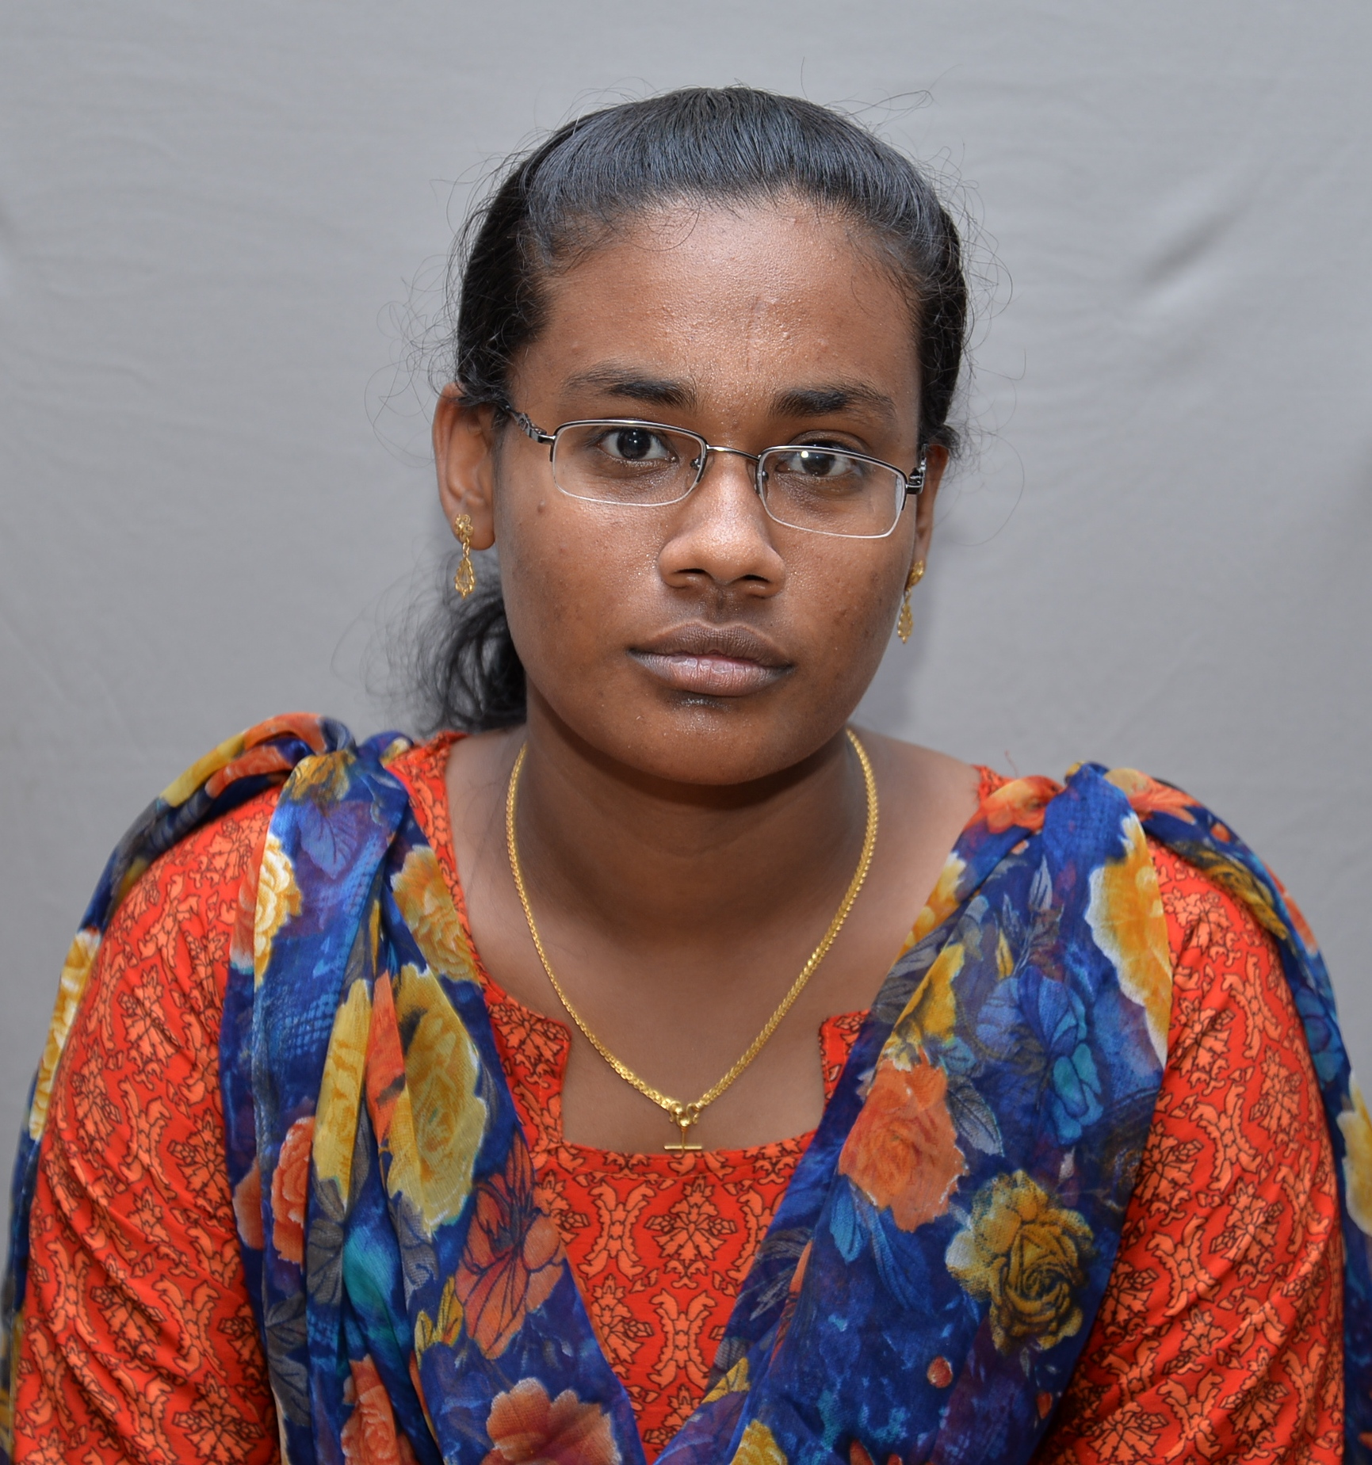
Name : Blessie Beulah K
Address : 74,II Issac Street,
Nazareth,Thoothukudi-628617.
D.O.B : 08.12.1993
Mobile No : 8903157746
Email Id : kbbeulah@gmail.com


Name : Chitra V
Address : Plot No 3,5th Street,
Rajendra Nagar,
Palayamkottai, Tirunelveli-627002.
D.O.B : 27.08.1992
Mobile No : 8903461995
Email Id : chitrasngth6@gmail.com

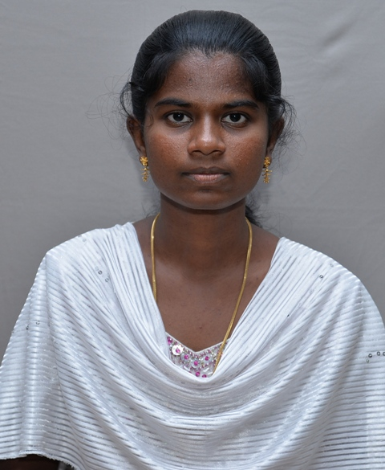
Name : Edinda Christy E
Address : 81,TNSCB Colony,Suthamalli Vilakku,
Tirunelveli-627604
D.O.B : 25.02.1994
Mobile No : 9443317705
Email Id : ytsirhce07@gmail.com

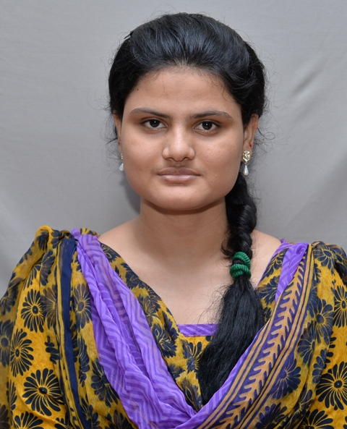
Name : Kadhirunnisa S
Address : 7B(1&2), 12th street,40 feet road,
Rahmath nagar,
Tirunelveli-627011
D.O.B : 10.12.1992
Mobile No : 9500322743
Email Id : nisasaji10@gmail.com

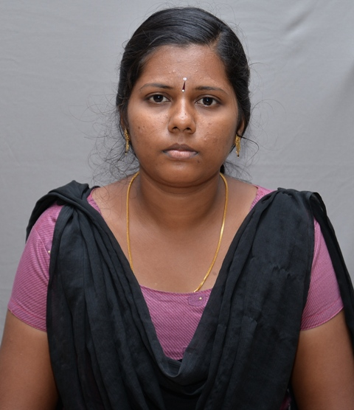
Name : Kalai Selvi K
Address : 29/57, North Street, Periyar Nagar,
Palayamkottai,Tirunelveli-627002.
D.O.B : 04.12.1991
Mobile No : 9944237681
Email Id : kakksch@gmail.com

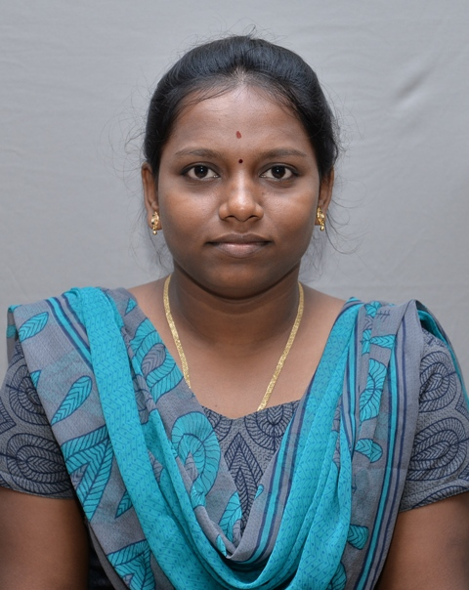
Name : Kavya C
Address : 35/2 B2 Thayaparan Street,
MuruganKuruchi,
Palayamkottai,Tirunelveli-627002.
D.O.B : 18.08.1992
Mobile No : 9600968441
Email Id : kavya.c1808@gmail.com

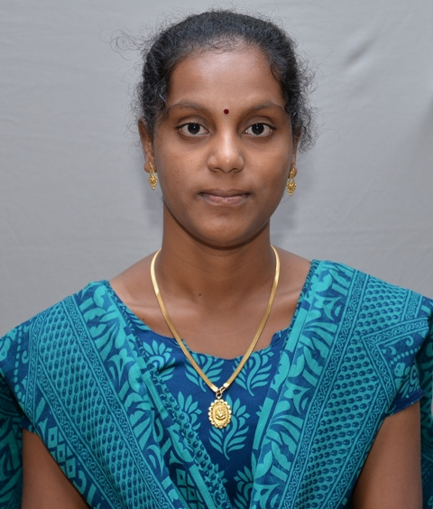
Name : Mala K
Address : 9A/15, Pillayar Kovil Street, Kayathar
Tuticorin-628952.
D.O.B : 07.04.1994
Mobile No : 8489625260
Email Id : kmala@gmail.com


Name : Rashmi Anns T
Address : 15/65A, Near Ricemill,Mela Asaripallam,
Nagercoil,Kanyakumari- 629201.
D.O.B : 06-06-1993
Mobile No : 9489812153
Email Id : annsrashmi@gmail.com

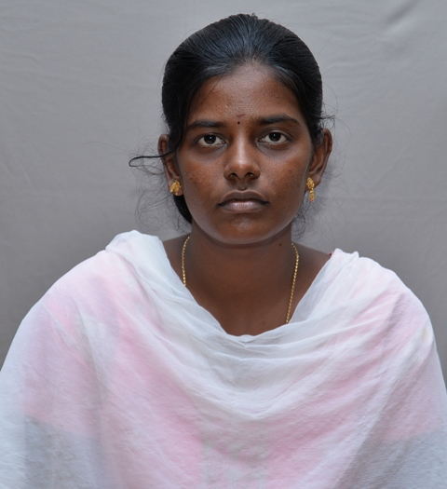
Name : Selvakani S
Address : L-34, Second Stage, Tnhb Colony,
V.M Chatram,
Tirunelveli-627011.
D.O.B : 01-06-1991
Mobile No : 9788132256
Email Id : sselvakani@gmail.com

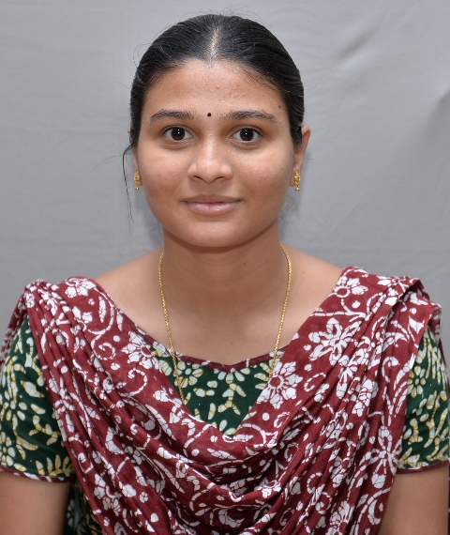
Name : Shunmuga Priya R.K
Address : 67/A, Sudalai Madasamy Kovil Street,
Tuticorin- 628002.
D.O.B : 10-08-1994
Mobile No : 9486320883
Email Id : priyaark94@gmail.com

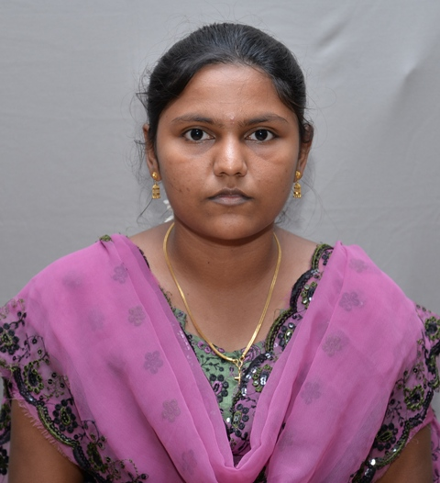
Name : Silvia Rachel S
Address : 2A, Bryant Nagar, 4th Street (Middle),
Tuticorin- 628008.
D.O.B : 19-05-1993
Mobile No : 9597964819
Email Id : s.silviarachel@gmail.com

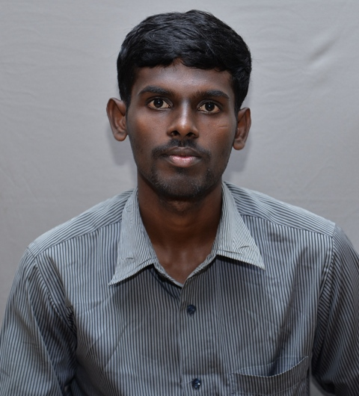
Name : Sorimuthu Iyan P
Address : 16-1,Lakshmipuram,
Petduraisamypuram,
Srivaikuntam-628601.
D.O.B : 02.05.1994
Mobile No : 8525056955
Email Id : sorimuthuiyan@gmail.com

